|  |  |  |
| --- | --- | --- |
| **Politechnika Świętokrzyska w Kielcach**  **Wydział Elektrotechniki Automatyki i Informatyki Katedra**  **Informatyki, Elektroniki i Elektrotechniki** | | |
| **Project:** Java | **Faculty:** Informatyka | |
| **Semester:**  **IV** | **Student name:**  Tarasenko Anastasiia | **Group:** 2IA11 |
| **Date:**  28.05.2020 | **Name of teacher:**  Adam Krechowicz | |
| **Project topic:**  Battleship | | |
|  |  | |

**Battleship** (also Battleships or Sea Battle) is a strategy type guessing game for two players. It is played on ruled grids (paper or board) on which each player's fleet of ships (including battleships) are marked. The locations of the fleets are concealed from the other player. Players alternate turns calling "shots" at the other player's ships, and the objective of the game is to destroy the opposing player's fleet.

**How to compile:**

If you want to play locally, for starters just compile the **Battleship.java** file with the command:

**javac Battleship.java**

Then to start the program write:

**java Battleship**

Next, you will see a window where you are asked to enter your nickname and then you will immediately have a window with the game grid, to start the game, first click on the **Game** button in the left corner of the screen and select **New Game** there. Then you will see a window in which you will have to choose how you want to play **Online** or **Locally**. If you select a local game, you will immediately see a field with two nets, the ships will be arranged automatically, you just have to play.

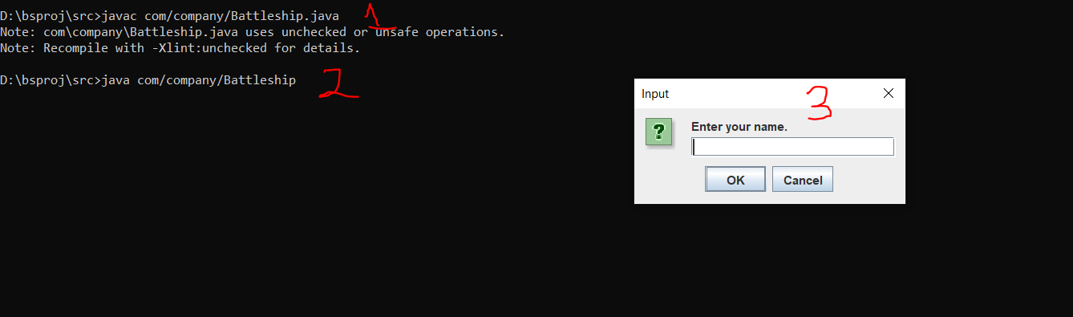

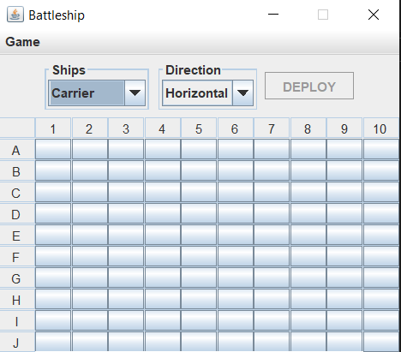

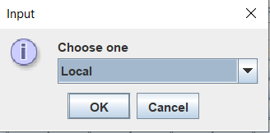

To play Online, you need to do almost everything just like I said above, but first, before starting the game, you need to compile and run the BattleshipServer.java file. After which you are again the same

run **Battleship.java** (on two computers), go to **Game**, select **New Game** and then select **Online**. Then arrange your ships and click **Deploy.**

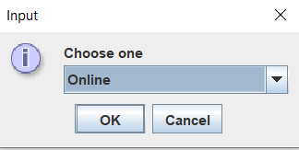

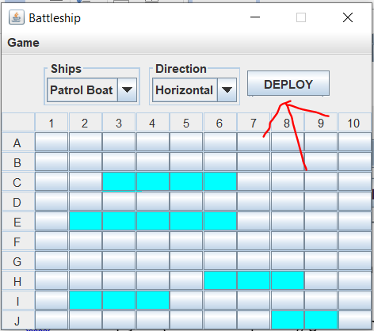

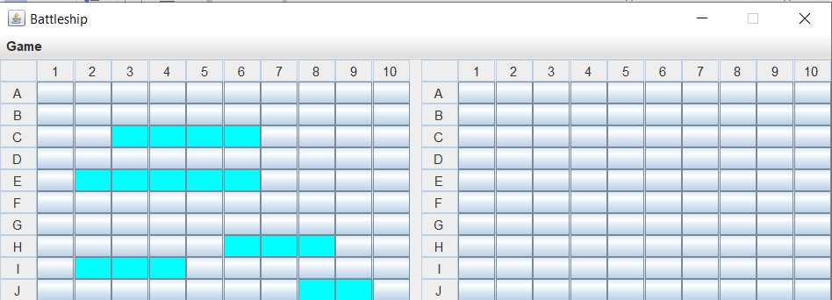

**Code:**

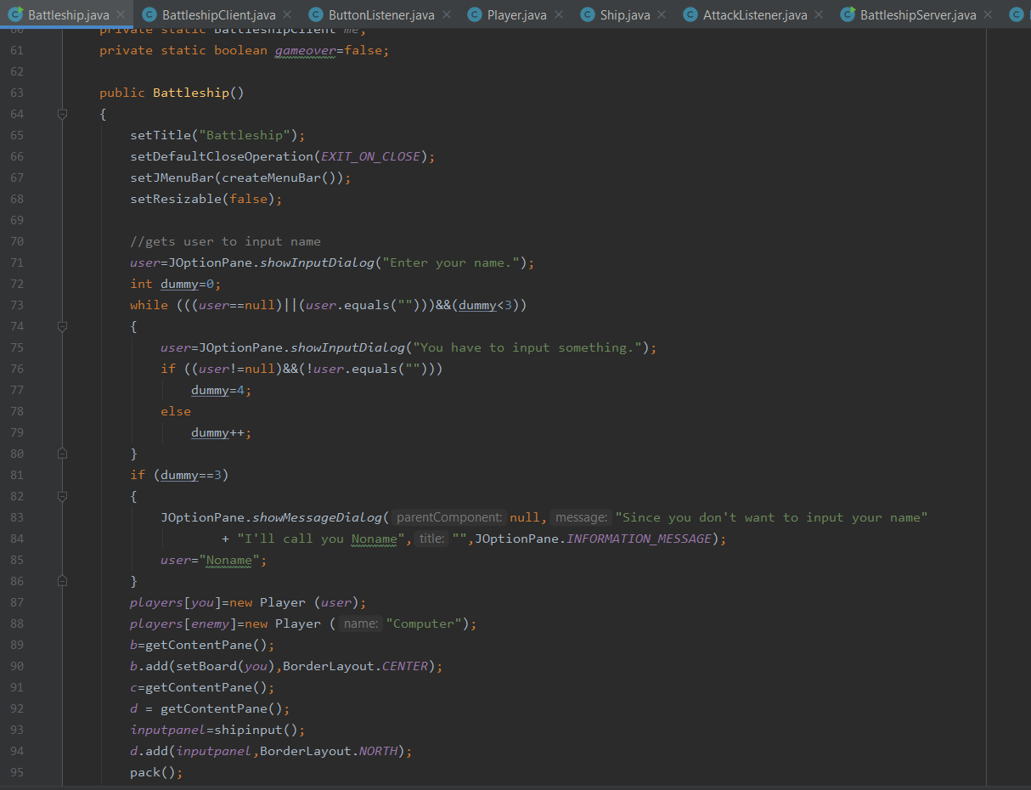

Above you can see the **Battleship** file, this file is essentially the basis of the whole game. In this part, all windows, buttons, different game menus are created, the character’s nickname and all the like are also entered, you can see more detailed comments directly in the code itself.

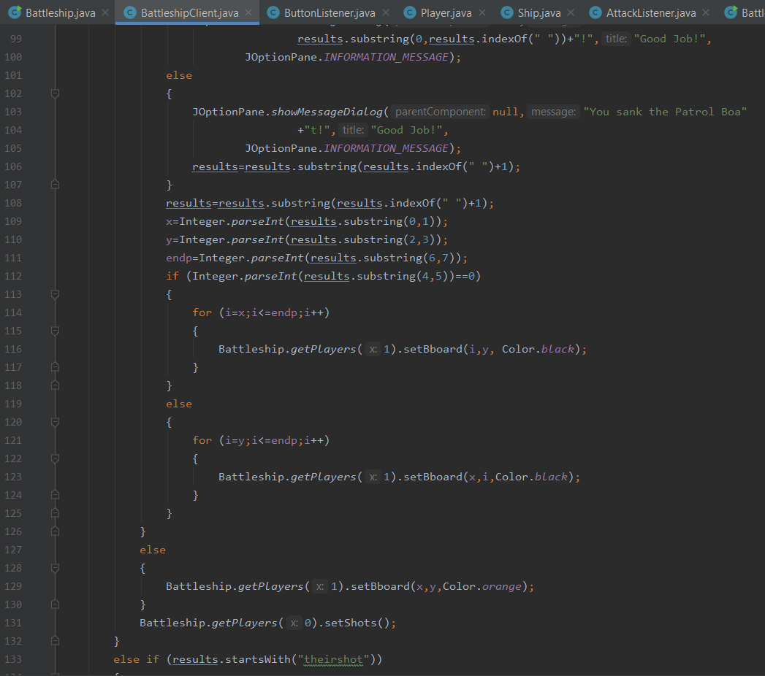

Above, in the **BattleshipClient** file, you can see the client part of the game in which the connection is checked, it is also checked whether you drowned the ship or not, if so, various kinds of messages are displayed. Messages are also displayed if you fired in the wrong turn or on the wrong field, or if you make a move for a very long time.

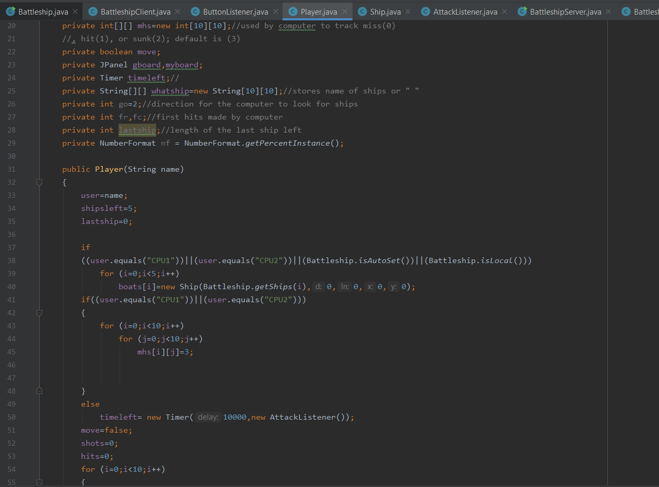

The **Player.java** file controls the actions, that is, shots, the location of the ships and everything like that, and also displays a message about winning or losing.

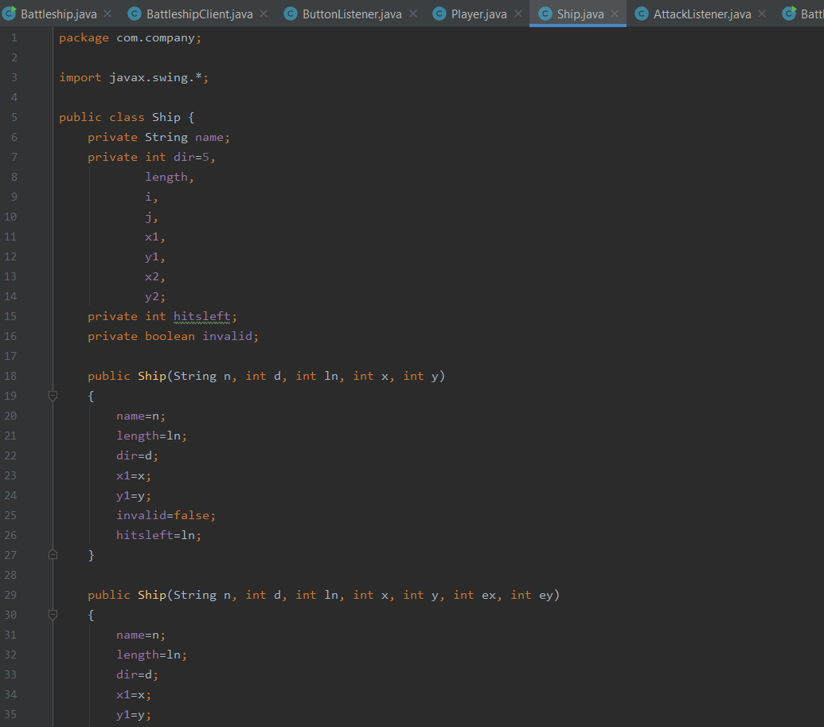

The **Ship.java** file stores data about the ships, namely their types, how they are located horizontally or vertically, their size and location on the map.

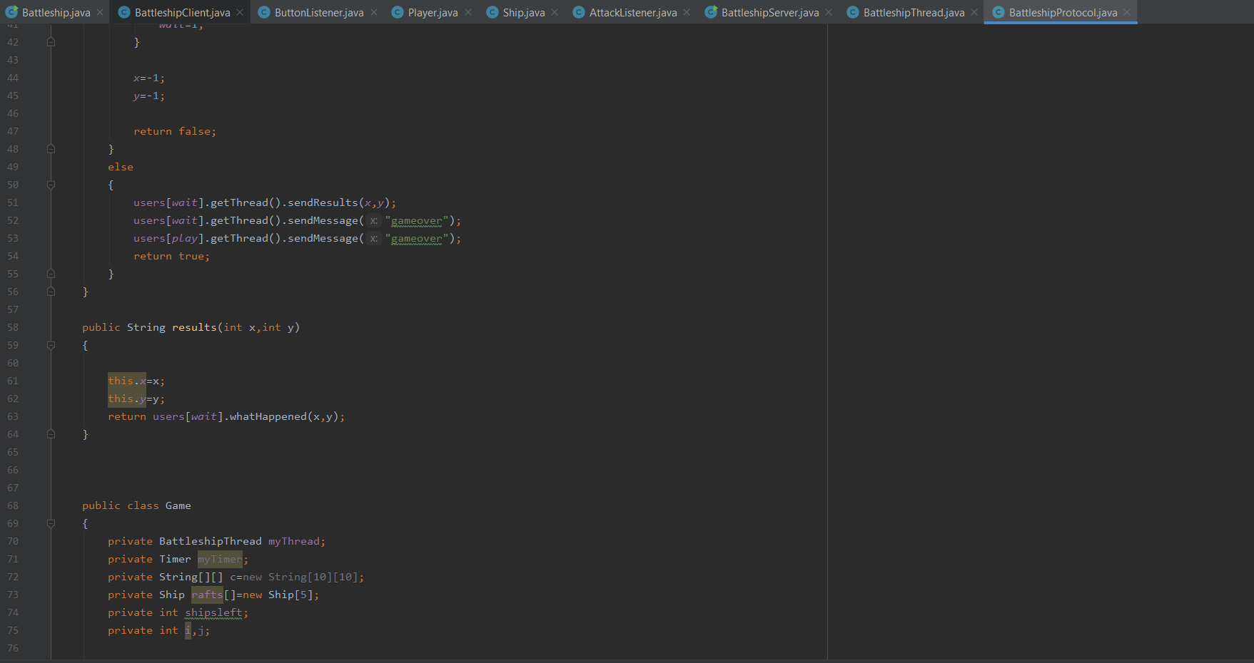

And also the last three files, namely **BattleshipServer, BattleshipProtocol and BattleshipThread** are used to create a network connection, namely, using the server we can connect and play our game online, notify players if one of them has not made their move, send messages about the player hit or not.